Final Report: CAD Project

“Your device name here”

Prof. Edward Gao

TA: Yaoyu Fan

Team 1

Joe Bruin

…

Smith McSmith

MAE-94: Computer Aided Design and Drafting

Summer 2024

Mechanical & Aerospace Engineering Department

University of California, Los Angeles

08/01/2024



Please put a picture of your team on this page

Pictured from left to right: J. Bruin, …, and S. McSmith



# Abstract

A max one-page summary of the report.

Table of Contents

Abstract iii

List of Figures v

List of Tables vi

List of Symbols vii

1. Introduction and General Background 8

2. Design Goals and Objectives 8

3. Prior Work (State-of-the-art) or Scientific History 9

4. Concept Development 10

4.1. Design Concept 1 10

4.2 Design Concept 2 10

4.3 Design Concept 3 10

4.4 Design Choice 10

5. Theoretical Calculations 11

6. Design Specifications 12

6.1 Final Design Description 12

6.2 Device Parts Design 13

6.3 Powering the Device 13

7. Manufacturing and Fabrication 13

8. Conclusions 14

9. References 14

10. Appendix 15

A. Parts Drawings: 15

B. ASSEMBLY Drawing: 19

# List of Figures

Figure 1: This is a shredding device manufactured by … [reference #] 9

Figure 2: Schematic of the initial design – “The Edge Cutter” [5] 10

Figure 3: Solid model of the final assembled device “The Shreeder” [##] 11

# List of Tables

Table 1: Device Dimensions 11

Table 2: Device Parts Masses 12

Table 3: Paper cutting performance of the Shredder 13

Table 4: Design Requirement Satisfaction 14

# List of Symbols

|  |  |  |
| --- | --- | --- |
| **Symbol** | **Description** | **Unit** |
| θ | Angle of blade | degree |
| F | Force | N |
| k | Spring constant | N/m |
| a | Acceleration | m/s2 |
| Lc | Distance from center of gravity | m |
| L | Length of device | m |
| h | Height of device | m |
| µ | Coefficient of friction | No units |
| … |  |  |
| … |  |  |

# Introduction and General Background

Splitting paper has become a difficult task for many graduate students. There is a need for a device that is capable of ….. Our objective is to develop a product that can meet the stated need and can …

In an effort to address the current product shortcomings, such as rusting and to fulfill the aforementioned need, we have designed a device that is made entirely of plastic and is capable of not only cutting a single piece of paper, but will be put to test in a competition to cut as many as 25 papers at once. The device is made of ABS (spell out what ABS stands for) or PLA (spell out) plastic and will be manufactured using …. The device must be built in accordance with several key design requirements, and ultimately will be pitted against competing designs. We are confident that our design will prove to be the most effective bulk paper splitter on the entire UCLA campus.

# Design Goals and Objectives

The design goals and objectives for this project are outlined below:

The device must….

1. …
2. …
3. …

…

Place a picture that exemplified the dynamic task your product should in theory do.

# Prior Work (State-of-the-art) or Scientific History

In this section you want to show the research you did on what devices are currently available to meet the need statement and your objectives. Conventional systems include scissors [1], shredding devices [2], dogs [3], blades [4], and knifes [5]. It is very important that you reference any product or process that you describe and add its reference to the reference section. Figure 1 shows and example of available products.



Figure 1: This is a shredding device manufactured by … [reference #][1]

We propose a revolutionary new and innovative product that not only surpasses all of the above listed devices, it does it better and a fraction of the cost!

# Concept Development

In this section you describe a number of design concepts and outline the logic for selecting the final design.

## 4.1. Design Concept 1

The preliminary design of our device was based on … [use your Concept Report material]

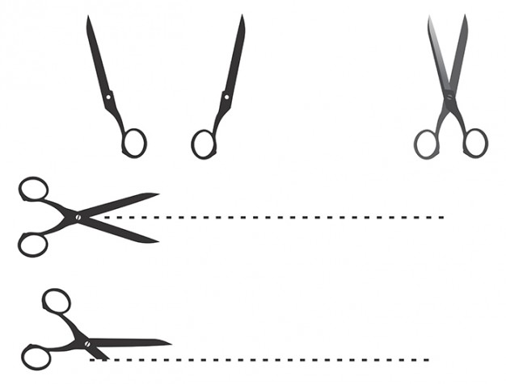

Figure 2: Schematic of the initial design – “The Edge Cutter” [5]

## 4.2 Design Concept 2

## 4.3 Design Concept 3

## 4.4 Design Choice

# Theoretical Calculations

In order to determine the total mass of our cutting device, we had to find the density of ABS plastic. The density is … kg/m3 [##]. All parts except …. were made of ABS. Using Solidworks the total mass of the device including all non-ABS parts was estimated to be …. Figure ## shows the center of gravity of the device (a side view should be presented here).

The stored potential energy of the rubber bands was estimated using Hook's law. Hooke’s Law states that the restoring force (F) provided by an ideal spring is proportional to the displacement (x) from equilibrium times a constant (𝑘) as given by equation (1):



Combining eq. (1) with Newton's second law of motion (eq. 2) we can determine k. To do so we used several items of known mass, such as ….



The elastic potential energy is then estimated using equation 3:



The mass was estimated first by measuring its weight and then compared with the mass calculated by using the “mass properties” feature of SolidWorks. The mass estimations for the complex parts in our design can be found below in Table 1.

Table 2: Mass, Force, and Displacement Data for estimating *k*. [FILL IN YOUR OWN DATA]

|  |  |  |  |
| --- | --- | --- | --- |
| **Weight Label** | **Mass (kg)** | **Force (N)** | **Displacement (m)** |
| A | 0.245 | 2.401 | 0.099 |
| B | 0.467 | 4.577 | 0.115 |
| C | 0.584 | 5.723 | 0.124 |
| D | 0.793 | 7.771 | 0.162 |
| E | 1.406 | 13.778 | 0.312 |
| F | 0.712 | 6.978 | 0.157 |

The data in Table 2 was plotted and is shown in Figure ?? and the constant of elasticity was determined using …

The total available potential energy was estimated to be …… N-m.

# Design Specifications

The device is made of 17 parts. In this section we outline the design specifications of each part and of the final product. …….

## 6.1 Final Design Description

In this section you describe the overall design, how many parts, how it works, etc. and you show figures of the device Solid Model from different angles, use labels to identify parts and functions, and use arrows to indicate direction of motion of various parts. Don’t forget to tell the reader how it is powered…

The overall dimensions of the device are given in Table 1. And Figure 2 shows the solid model of the Shredder.

Table 1: Device Dimensions

|  |  |
| --- | --- |
| Parameter | Value |
| Length | 29 mm |
| Height | 21 mm |
| Width | 15 mm |
| Weight | 194 gr |

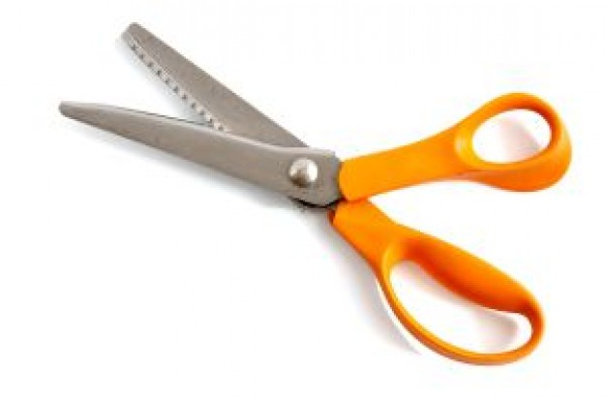

Figure 3: Solid model of the final assembled device “The Shreeder” [##]

Finish this section with an **exploded view** (tell the reader that a full size exploded view and full size assembly drawing are available in Appendix B – put a full size rotated exploded view and assembly drawing into Appendix B – I have already rotated the pages for you)

## 6.2 Device Parts Design

In this section you describe the individual parts and show solid models of all the parts, with detailed description. Don’t just say here is Part 1, instead explain the part what its primary function is, does is experience the majority of force, is it likely to fail, why you put cuts into to is, what are the functions of the rounds, or fillets, or chambers, why it is thick or thin …..

Put engineering drawings (dimensioned) into Appendix-A and let the reader know that detailed engineering drawings are in Appendix A.

## 6.3 Powering the Device

The device is propelled by 3 rubber bands by wrapping (twisting or stretching….…. Figure ?? shows how the rubber bands are attached and wrapped (or twisted or …)

# Manufacturing and Fabrication

Describe the manufacturing process for each parts, the material used, number of parts made, post-fabrication detailing, and any possible cost each process may undertake.

# Conclusions

As a result of various design iterations, the completed paper splitting device, the SHREDDER is an assembly of 17 parts. All the parts …..

Three different concepts were considered ….

The following design was chosen, because ….

Solid Modeling was performed, and parts drawings as well as an assembly drawing was produced.

Fabrication was tedious because ….

Performance was tested and ….

Lessons learned from designing and manufacturing this device …..

# References

1. …..
2. …..
3. …..
4. …..
5. <http://www.freepik.com/free-vector/cutting-edge-scissor-vectors_519781.htm>, accessed 12/05/2012

# Appendix

## A. Parts Drawings:

In this appendix we post the engineering drawings of all the parts….

PLEASE MAKE SURE YOU PUT A FIGURE NUMBER AND A FIGURE CAPTION AT THE BOTTOM OF EACH FIGURE.

I HAVE ROTATED THE NEXT SECTION AND I EXPECT THAT ALL DRAWINGS COMPLETELY FILL THE PAGE (EXCEPT FOR THE MARGINS AND THE FIGURE CAPTION).

Remember to use “save to PDF ” in Solidworks for reproducing drawings.

## B. ASSEMBLY Drawing:

In this appendix we present the assembly drawings of the device ….

PLEASE MAKE SURE YOU PUT A FIGURE NUMBER AND A FIGURE CAPTION AT THE BOTTOM OF EACH FIGURE.

I HAVE ROTATED THE NEXT SECTION AND I EXPECT THAT ALL DRAWINGS COMPLETELY FILL THE PAGE (EXCEPT FOR THE MARGINS AND THE FIGURE CAPTION).

Remember to use the “save to PDF ” method for capturing drawings from SolidWorks.

1. Here you put the reference number [#] and you put the same [#] in the Reference Section (at the end of the report). Give enough information so the reader could find the reference material.